**1.INTRODUCTION**

1.1 Overview

AN EV is a acronym for an electric vehicle.EVs are vehicles that are either partially or fully powered on electric power.Electric vehicles have low running costs as they have less moving parts for maintaining and also very environmentally friendly as they use little or more fossil fuels.

1.2 Purpose

Electric vehicles use electricity to charge their batteries instead of using fossil fuel like petrol or diesel.Electric vehicles are more efficient,and that combined with the electricity

**2.Problem Definition & Design Thinking**

**2.1 Empathy Map**

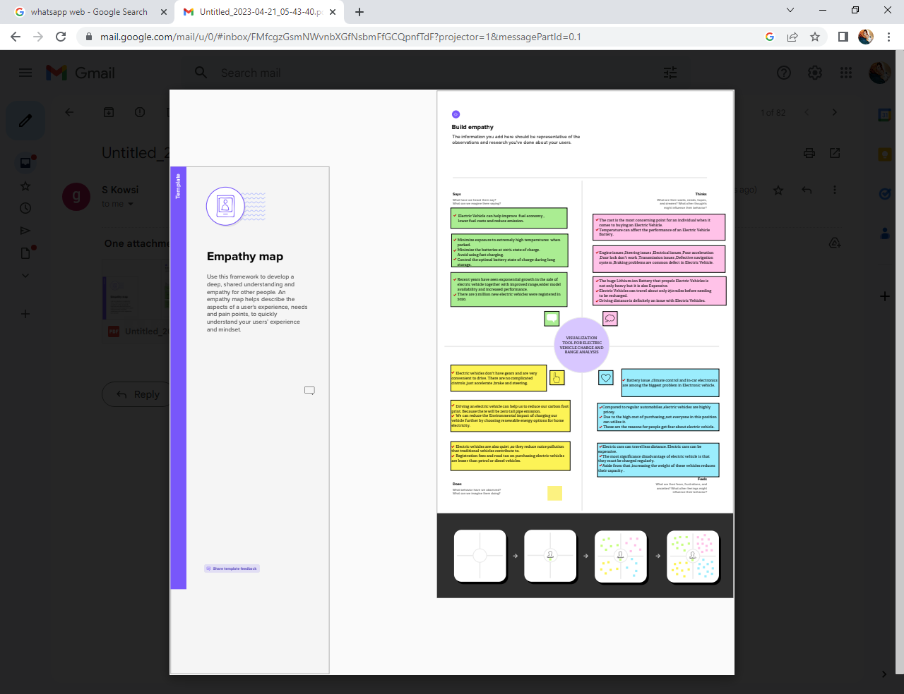

**2.2 Ideation & Brainstorming Map**

**3 RESULT 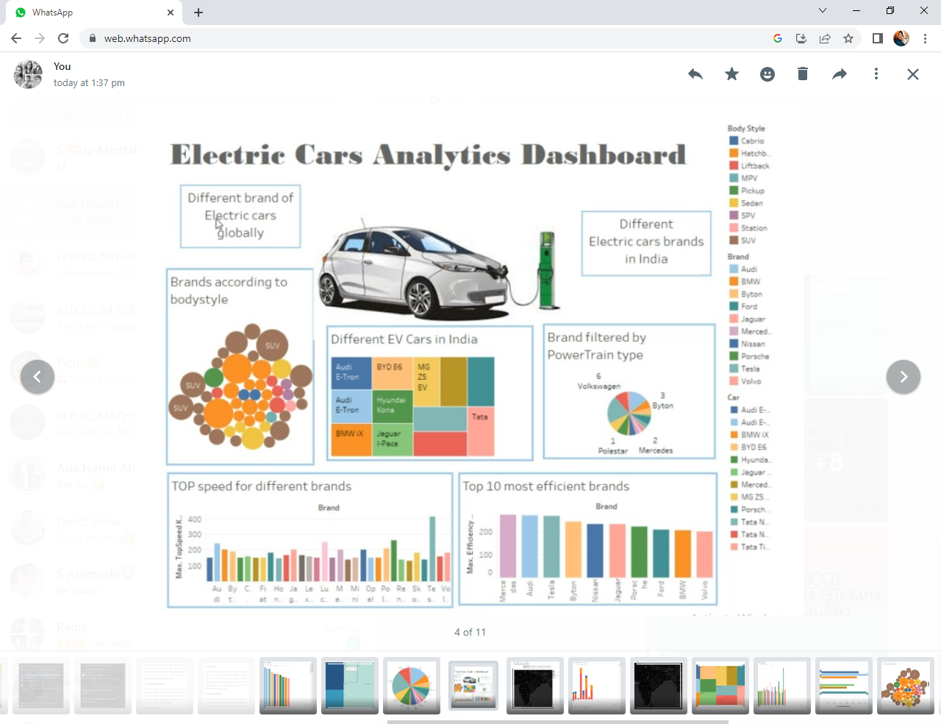PPP**



**4. Advantages & Disadvantages**

**Advantage ;**

**Better Performance**Electric cars are not only lighter but have faster acceleration

**No fuel required so you save money on gas**  
Paying $0.10 per kW is the equivalent of driving on gasoline that costs less than $1 per gallon. On average, drivers save about $700 in fuel costs per year while driving electric cars.

**Lower maintenance due to an efficient electric motor**  
Electric motors have less parts that lead to less damage than a traditional non **Environmental friendly as they do not emit pollutants**Drivers of electric vehicles have reduced CO2 emissions by more than 177,758,80

**Disadvantages;**

* Limited Battery Range. The average petrol car can easily do four or five hundred miles on a tank of petrol.
* Battery Lifespan Concerns.
* Charging Infrastructure Worries.
* Long Charging Times.
* Low Top Speeds.
* More Expensive to Buy.
* Environmental Impact.
  1. APPLICATION
* Public Transportation.
* Aviation.
* Electricity Grid.
* Renewable Energy Storage.
* Military.
* Spaceflight.
* Wearable Technolog
  1. **conclusion**

**The need for reliable, affordable, and environmentally sound electricity grows more vital every year. With the support of the public, the federal government, and the states, renewable energy sources will play a larger role in fulfilling these goals. Renewables, along with the full range of other climate-friendly technologies—including nuclear, energy efficiency, clean coal, carbon capture and storage, and plug-in electric hybrids—must all be a part of the electric power industry’s long-term future.**

* 1. **FUTURE SCOPE**

**Electric vehicles now include cars, transit buses, trucks of all sizes, and even big-rig tractor trailers that are at least partially powered by electricity.**

Electric vehicles fall into three main categories:

* **Battery electric vehicles** are powered by electricity stored in a battery pack.
* **Plug-in hybrids** combine a gasoline or diesel engine with an electric motor and large rechargeable battery.
* **Fuel cell vehicles** split electrons from hydrogen molecules to produce electricity to run the motor
  1. **APPENDIX;**

**1.**[**https://public.tableau.com/views/electric_vehiclecharging/Dashboard1?:language=en-US&:display_count=n&:origin=viz_share_link**](https://public.tableau.com/views/electric_vehiclecharging/Dashboard1?:language=en-US&:display_count=n&:origin=viz_share_link)

**2.**[**https://public.tableau.com/views/ElectricCarsProject/StoryofElectricCarsinIndia?:language=en-US&publish=yes&:display_count=n&:origin=viz_share_link**](https://public.tableau.com/views/ElectricCarsProject/StoryofElectricCarsinIndia?:language=en-US&publish=yes&:display_count=n&:origin=viz_share_link)